Curriculum Vitae
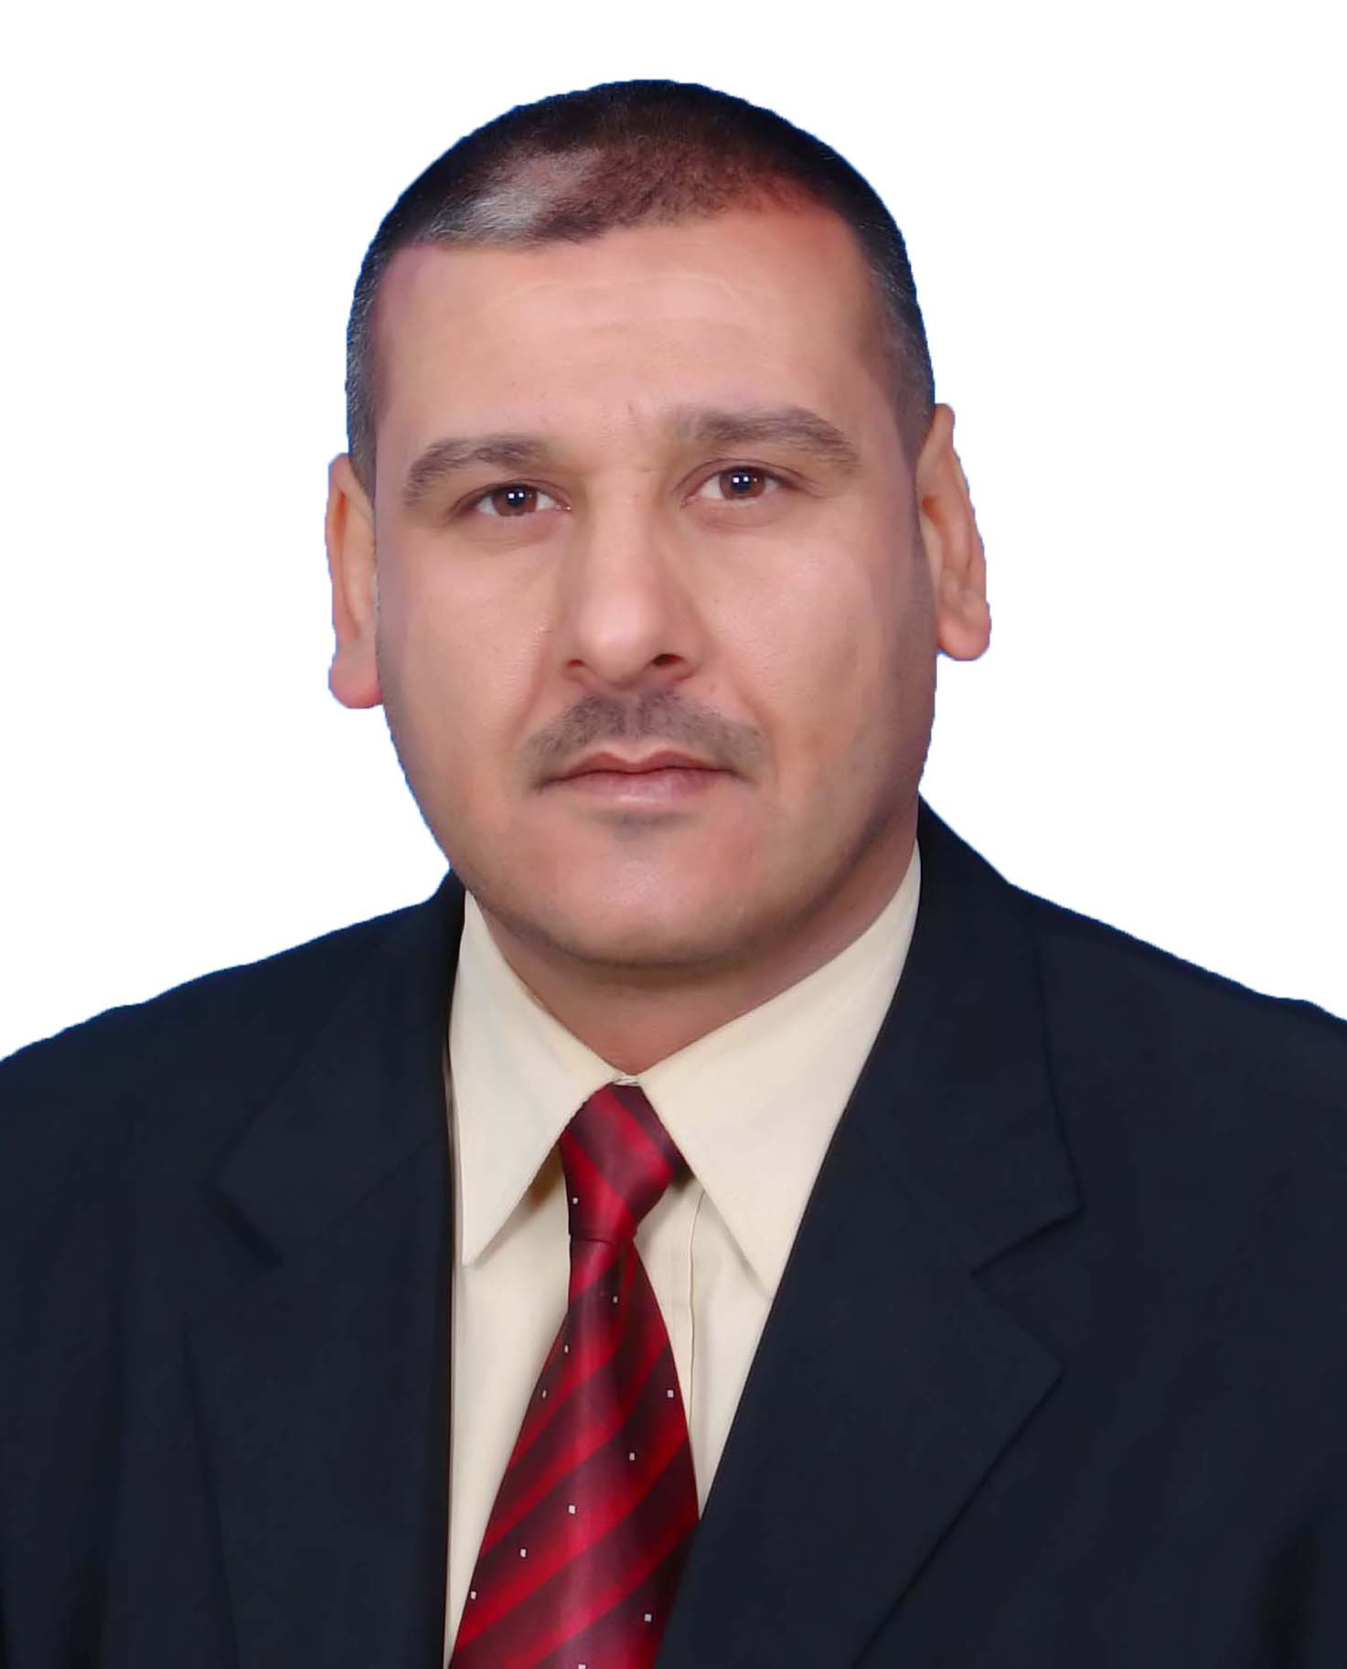

A. Personal Data :
- Full Name: HaleemHamzaHussian .
- Scientific Degree: assistant professor
- Sex: Male.

- Date And Place of Birth: 5/ 8 /1975 – suiwara– Wasit – Iraq.

- Marital Status: Married with five children, 2 girls and 3boys.
- Religion: Moslem.
- Nationality: Iraqi.
- Languages Spoken: Arabic and English
- Mobile phone : 07711230747
- E-mail: haleem75@yahoo.com

B. Specialization:
- B.Sc. in Veterinary medicine and surgery/College of Vet. Med. University of Baghdad /1999.With good grade and from the first students
- M.Sc. in parasitology/ College of Vet. Med. University of Baghadad/ 2003.with a excellent grade and from the first students
- Ph.D. student until now

C. Employment Years : (15) fiftyyears in ministry of higher education and Scientific Research / Iraq.

- The appointment date is 15/1/2005 as a Teaching Assistant at the College of Veterinary Medicine, Dyiala

- Participate in many development courses,conferences and scientific symposium held at the college and university.

- Present position: lecturer in Department of Internal Medicine and Preventive/ College of Vet. Med. University of Diyala/ Iraq.

D. Teaching Experience

Teaching the subjects biology (2 years) for undergraduate students in the Dept. microbiology / College of Vet. Med. / University of Diyala / Iraq during the interval 2005 – 2007.

2- Teaching the subjects medical parasitology Theory and Practical for undergraduate students in the Dept. micobiology / College of Med. / University of wasit / Iraq from 2007-2008.

3- Teaching the subjects parasitology 3 stages for undergraduate students / College of Vet. Med./ University of Diyala/ Iraq during the interval from 2009 until now.

E. Published Research Papers

No | Title of research | Journal name and Publisher
1 | حسين , حليم حمزة (2009 ) . دراسة التغيرات النسيجية والعيانية في جلود الماعز المحلي المصابة بحلم الجرب في بغداد . | مجلة ديالى للعلوم الزراعية . المجلد(1) العدد(1)
2 | حسين , حليم حمزة . يعقوب , عالية يوسف (2010) اانتشار الطفيليات الخارجية على الأغنام المحلية في بغداد) | . مجلة ديالى للعلوم الصرفة . المجلد (6) العدد( خاص
3 | حسين ، حليم حمزة. عباس, ابراهيم صالح ( 2011) دراسة تأثير بعض المستخلصات النباتية على طفيلي القراد جنس ( ( Hyalomma | مجلة جامعة كربلاء العلمية . العدد(57)
4 | Hasson , RaadHammodi and Al-Zubaidi, HaleemHamza (2011) Ectoparasite of Rodents from some districts in Baghdad. | Jour.ofwassit science and medicine vol4. no2.
5 | Hasson , RaadHammodi and Al-Zubaidi, HaleemHamza(2012) Sheep and goats tick's infestation in Wasit'sdistricts.Iraq. | Journal of vetrinary medicine. vol36 .special issue.
6 | Hasson , RaadHammodi and Al-Zubaidi, Haleemhamza.(2013) cattle and buffalos ticks infestation of wasit province .. | Kufa.Journal of veterinary medicine science vol 9. no 1
7 | حسين , حليم حمزة و علي , معن عبد المنعم(2014) دراسةانتشار حلمالجربالساركوبتيعلىالأغنامالمحلية فيمحافظةديالى. | . مجلة ديالى للعلوم الصرفة . المجلد 10العدد 3
8 | الزبيدي, حليم حمزة حسين(2014) عزل وتشخيص بعض الطفيليات الخارجية والداخلية في الدجاج المحلي في ديالى . | .مجلة القادسية لعلوم الطب البيطري. المجلد14 العدد2

9
10 | دراسة انتشار الطفيليات الخارجية على الابقار المحلية في محافظة ديالى | مجلة الفرات للعلوم الزراعية .مؤتمر القاسم الخضراء كلية الطب البيطري  8(1) :1…10 2015
11 | Minnat, TareqRifaaht; Alzubaidei, HaleemHamzaHussain, and Al-Ezzy, Ali Ibrahim Ali(2014). Heamatological Changes Associated with Gastrointestinal Parasites Infection in Domestic Animals attended to Outpatient Clinic of Faculty of Veterinary Medicine of Diyala University, Iraq. | International Journal of Innovation and Applied Studies. Vol. 9 No. 3 pp. 1266-1274

